Information for Fathers & Partners

The postpartum adjustment for all family members is often an overwhelming and confusing experience. Though a happy and joyful event, the welcoming of a newborn into your family may also be a source of stress and anxiety during this time.

You may be the first one to recognize that your partner is exhibiting signs of a Postpartum Anxiety or Depression (PPD), and you will become her life-line toward treatment and support. PPD often inhibits the mother’s ability to care for herself and the baby. She has no control over her self-doubts, fears and emotional upset. You will need to provide the family leadership for
the baby’s and mother’s health and safety.

Help is available through your family physician, the doctor who delivered your baby, or the baby’s doctor. Reach out and ask for help. It may take some time for the combination of medication and psychotherapy to work effectively to control the symptoms of Postpartum Anxiety and Depression.

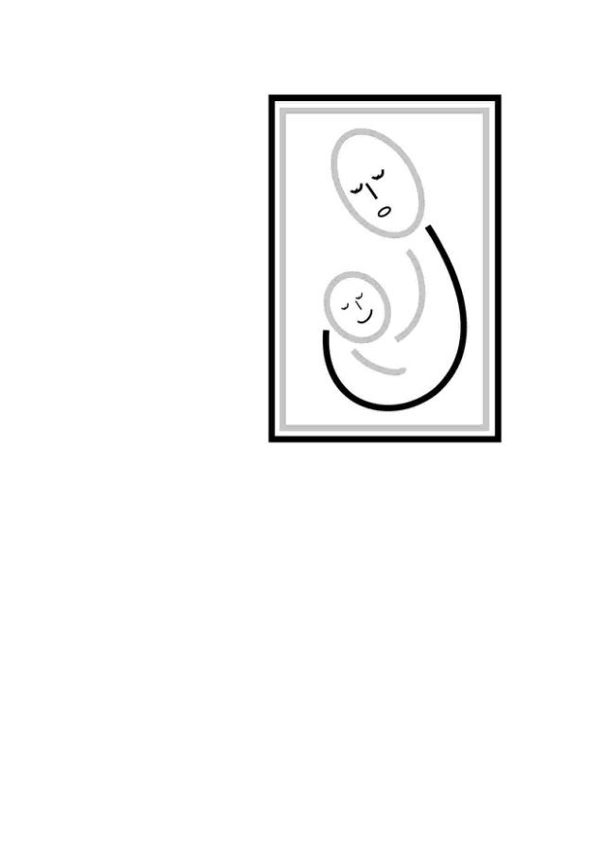
Here is what you can do to help your partner until she feels like herself again:

- BE EMPATHIC – Show love and compassion, not anger or impatience.
- BE NON-JUDGEMENTAL – Reassure, don’t criticize.
- BE OBSERVANT – Report what you observe to the doctors and nurses.
- BE AWARE – Of your partner’s concerns and feelings.
- BE AVAILABLE – Be present and actively involved with your newborn.
- BE PATIENT – This will go away. It will get better.
- BE COLLABORATIVE – Work with our resources toward shared goals.
- BE A FATHER – Active interest and participation prevents isolation.

The leadership you provide for your family during this difficult adjustment will empower all of you toward health, happiness, and strong family relationships.
Printed with permission by Depression After Deliver (D.A.D.) Inc. and the author, Diane Cuff Carney, APRN, BC

