Name: ………………………….
……………………………………
DOB: …………………………..

Women and Newborn Health Service
King Edward Memorial Hospital
Western Australia
Women’s Health Care Clinical Care Unit (WHCCU)

Department of Psychological Medicine

Perinatal Anxiety Screening Scale (PASS)

ANTENATAL POSTNATAL DATE: ……………………………

Weeks pregnant ………… Baby’s age ………………..

Over the past month, how often have you experienced the following? Please tick the response that most closely describes your experience for every question.

 | Not at all | Some times | Often | Almost Always
1. Worry about the baby/pregnancy | 0 | 1 | 2 | 3
2. Fear that harm will come to the baby | 0 | 1 | 2 | 3
3. A sense of dread that something bad is going to happen | 0 | 1 | 2 | 3
4. Worry about many things | 0 | 1 | 2 | 3
5. Worry about the future | 0 | 1 | 2 | 3
6. Feeling overwhelmed | 0 | 1 | 2 | 3
7. Really strong fears about things, eg needles, blood, birth, pain, etc | 0 | 1 | 2 | 3
8. Sudden rushes of extreme fear or discomfort | 0 | 1 | 2 | 3
9. Repetitive thoughts that are difficult to stop or control | 0 | 1 | 2 | 3
10. Difficulty sleeping even when I have the chance to sleep | 0 | 1 | 2 | 3
11. Having to do things in a certain way or order | 0 | 1 | 2 | 3
12. Wanting things to be perfect | 0 | 1 | 2 | 3
13. Needing to be in control of things | 0 | 1 | 2 | 3
14. Difficulty stopping checking or doing things over and over | 0 | 1 | 2 | 3
15. Feeling jumpy or easily startled | 0 | 1 | 2 | 3
16. Concerns about repeated thoughts | 0 | 1 | 2 | 3
17. Being 'on guard' or needing to watch out for things | 0 | 1 | 2 | 3
18. Upset about repeated memories, dreams or
0 1 2 3
nightmares

Continued on Back
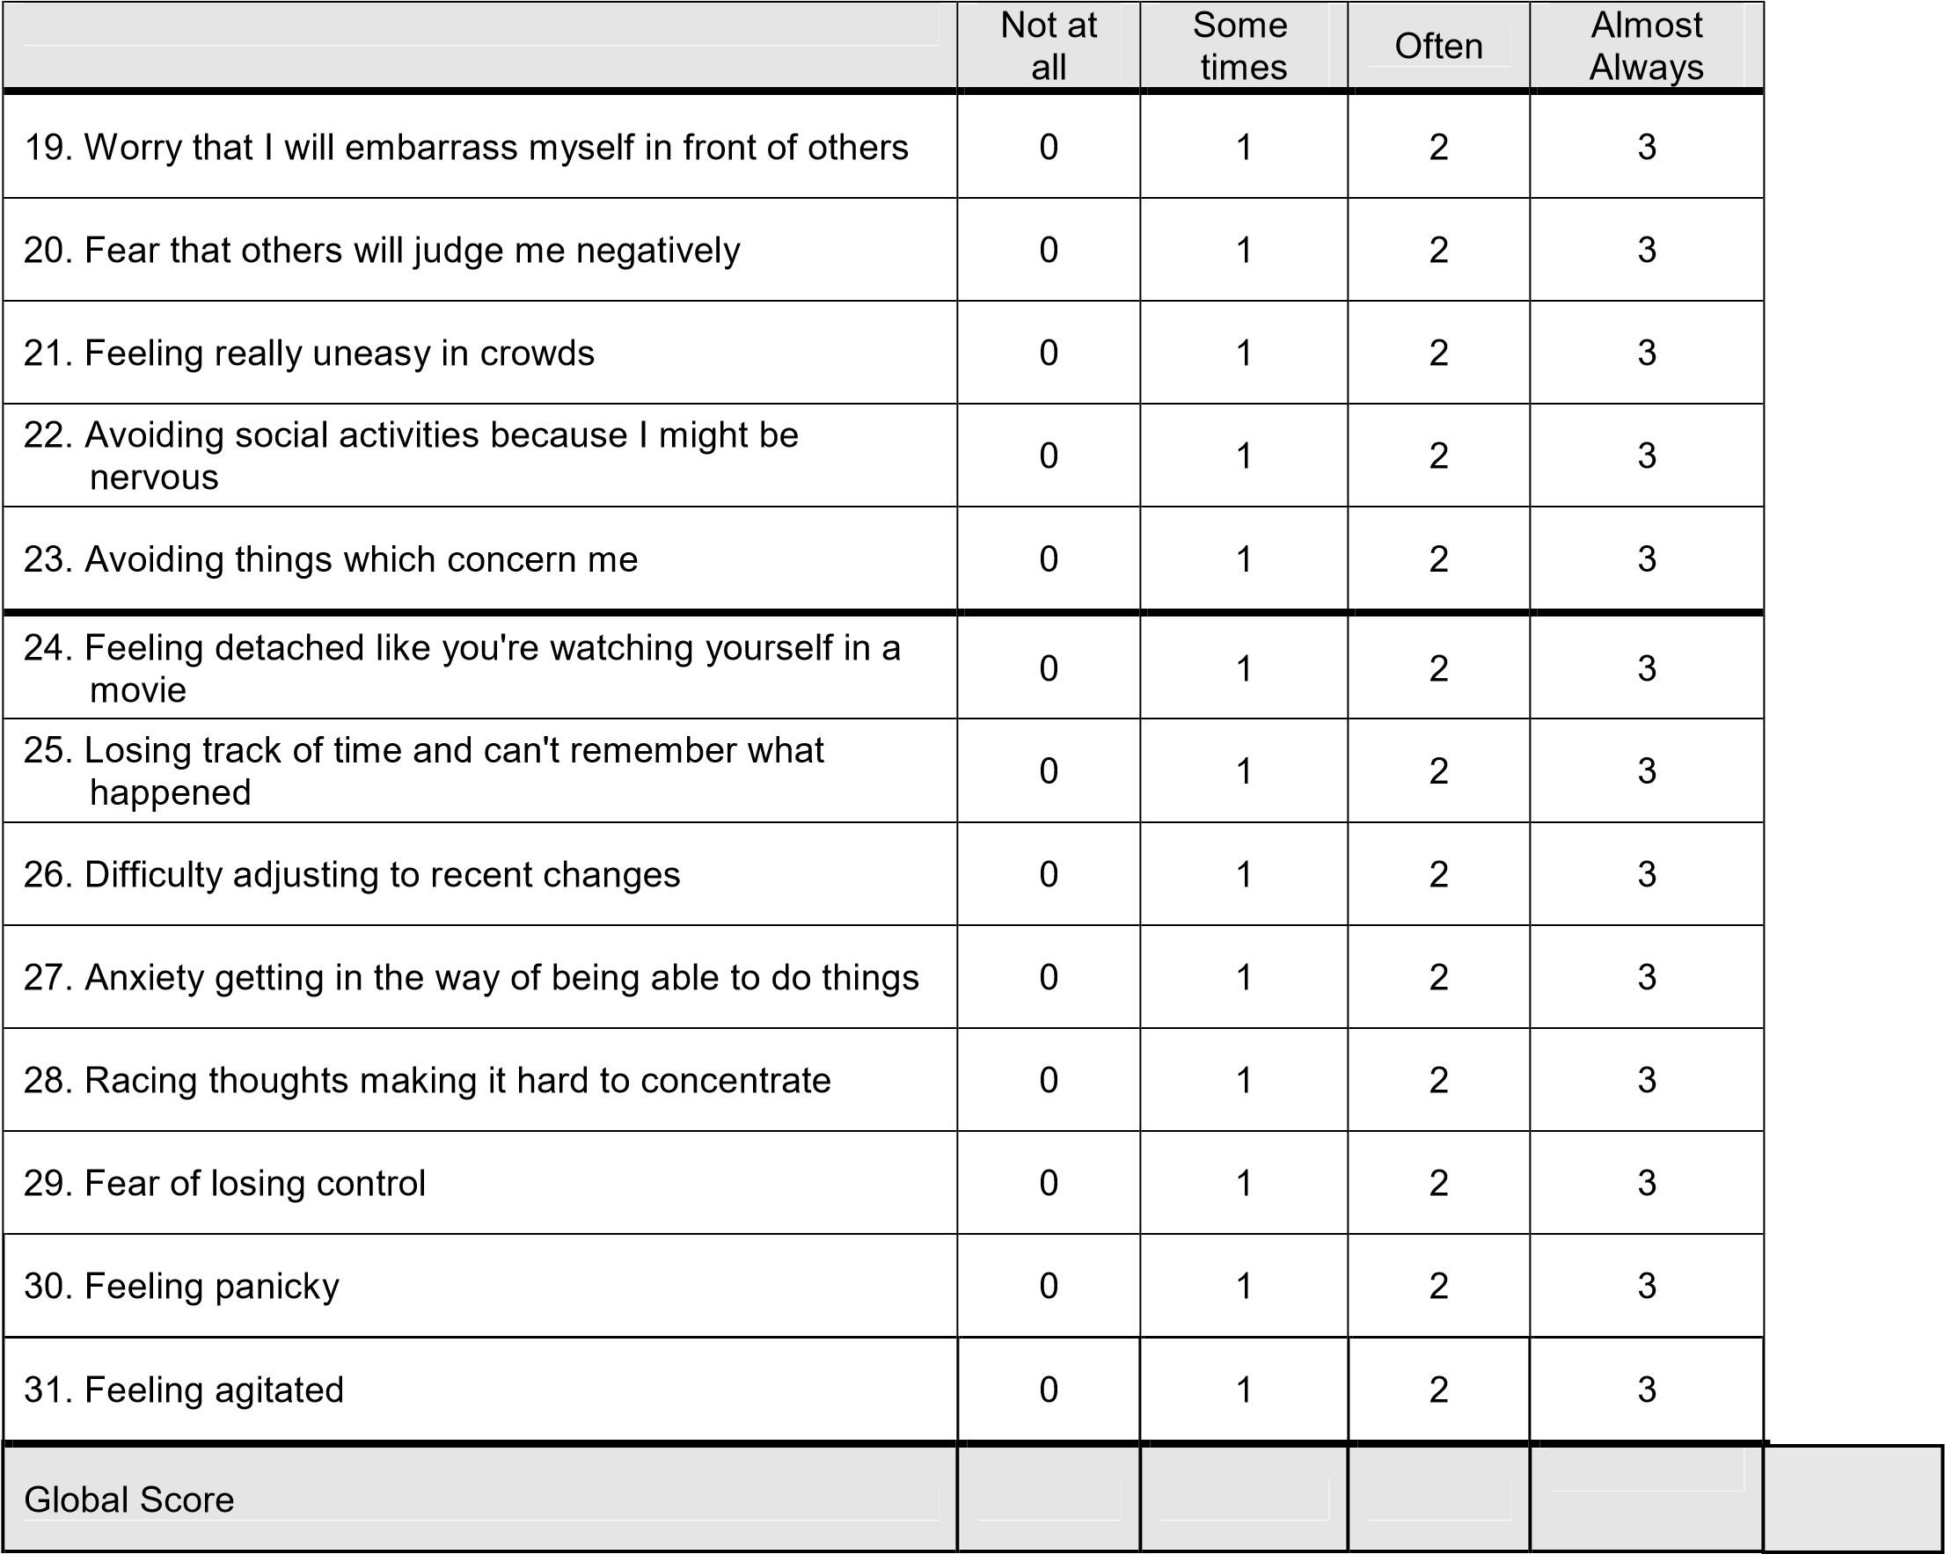

Reference:
Somerville, S., Dedman, K., Hagan, R., Oxnam, E., Wettinger, M., Byrne, S., Coo, S., Doherty, D., Page, A.C. (2014).
The Perinatal Anxiety Screening Scale: development and preliminary validation. Archives of Women’s Mental Health, DOI: 10.1007/s00737-014-0425-8
© Department of Health, State of Western Australia (2013)
Copyright to this material produced by the Western Australian Department of Health belongs to the State of Western Australia, under the provisions of the Copyright Act 1968 (Commonwealth of Australia). Apart from any fair dealing for personal, academic, research or non-commercial use, no part may be reproduced without written permission of the Department of Psychological Medicine, Women and Newborn Health Service, WA Department of Health. Please acknowledge the authors and the WA Department of Health when reproducing or quoting material from this source.

